**Ideation Phase**

**Define the Problem Statements**

|  |  |
| --- | --- |
| Date | 22 June 2024 |
| Team ID | SWTID1719933836 |
| Project Name | Connectify |
| Maximum Marks | 3 Marks |

**Customer Problem Statement Template:**

Create a problem statement to understand your customer's point of view. The Customer Problem Statement template helps you focus on what matters to create experiences people will love.

A well-articulated customer problem statement allows you and your team to find the ideal solution for the challenges your customers face. Throughout the process, you’ll also be able to empathize with your customers, which helps you better understand how they perceive your product or service.

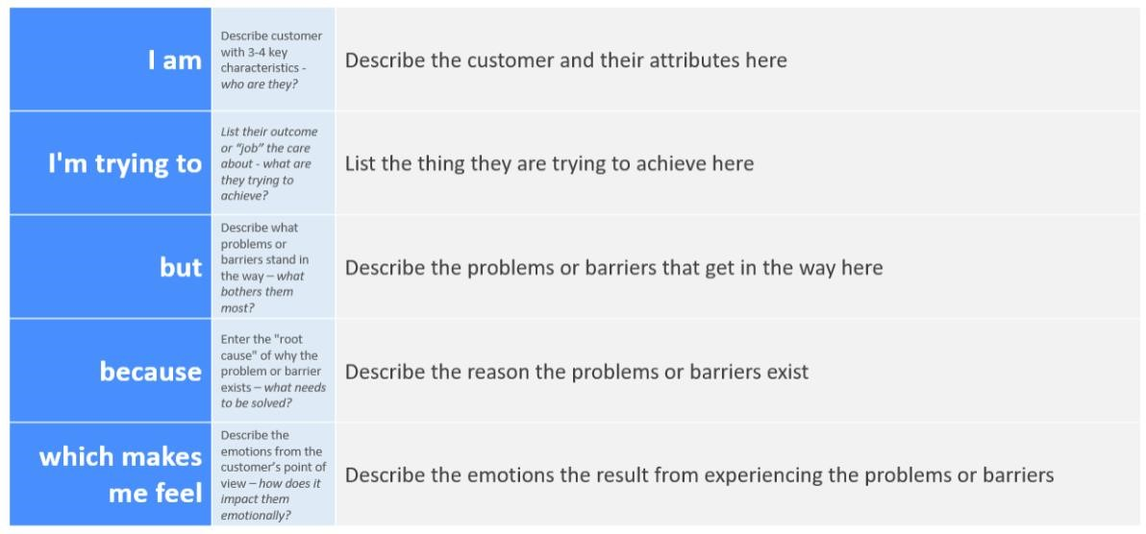

Reference: <https://miro.com/templates/customer-problem-statement/>**Example:**

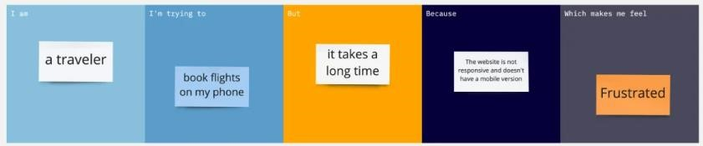

|  |  |  |  |  |  |
| --- | --- | --- | --- | --- | --- |
| **Problem**  **Statement (PS)** | **I am**  **(Customer)** | **I’m trying to** | **But** | **Because** | **Which makes me feel** |
| PS-1 | teenager | connect and share updates with friends | I'm having trouble finding them | the search tool is limited and not intuitive | frustrating and makes me feel alone. |
| PS-2 | business owner | to market my goods and interact with customers | my posts are not reaching a wider audience | the algorithm favours content from bigger brands | ignored and frustrated when I see that my posts aren't reaching as many people as they should. |
| PS-3 | content creator | engage with my audience and increase my following | the engagement metrics are confusing and hard to track | the analytics dashboard is busy and difficult to use | unconnected and uncertain about my success |
| PS-4 | privacy-conscious user | protect my personal information on the site, | I'm having trouble understanding the privacy options | they’re confusing and don't make sense | anxious |
|  |  |  |  |  |  |